Digital-Nurture-5.0-Deep-Skilling-Java-hands-on-exercise WEEK 1
Exercise 1: Inventory Management System
Scenario:
You are developing an inventory management system for a warehouse. Efficient data storage and retrieval are crucial.
Steps:
- Understand the Problem:
  - Explain why data structures and algorithms are essential in handling large inventories.
  - Discuss the types of data structures suitable for this problem.
- Setup:
  - Create a new project for the inventory management system.
- Implementation:
  - Define a class Product with attributes like productId, productName, quantity, and price.
  - Choose an appropriate data structure to store the products (e.g., ArrayList, HashMap).
  - Implement methods to add, update, and delete products from the inventory.
- Analysis:
  - Analyze the time complexity of each operation (add, update, delete) in your chosen data structure.
  - Discuss how you can optimize these operations.

OUTPUT :
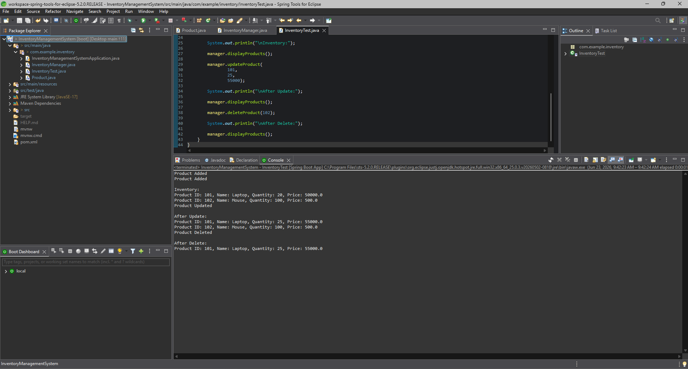

Exercise 7: Financial Forecasting
Scenario:
You are developing a financial forecasting tool that predicts future values based on past data.
Steps:
- Understand Recursive Algorithms:
  - Explain the concept of recursion and how it can simplify certain problems.
- Setup:
  - Create a method to calculate the future value using a recursive approach.
- Implementation:
  - Implement a recursive algorithm to predict future values based on past growth rates.
- Analysis:
  - Discuss the time complexity of your recursive algorithm.
  - Explain how to optimize the recursive solution to avoid excessive computation.

OUTPUT :
